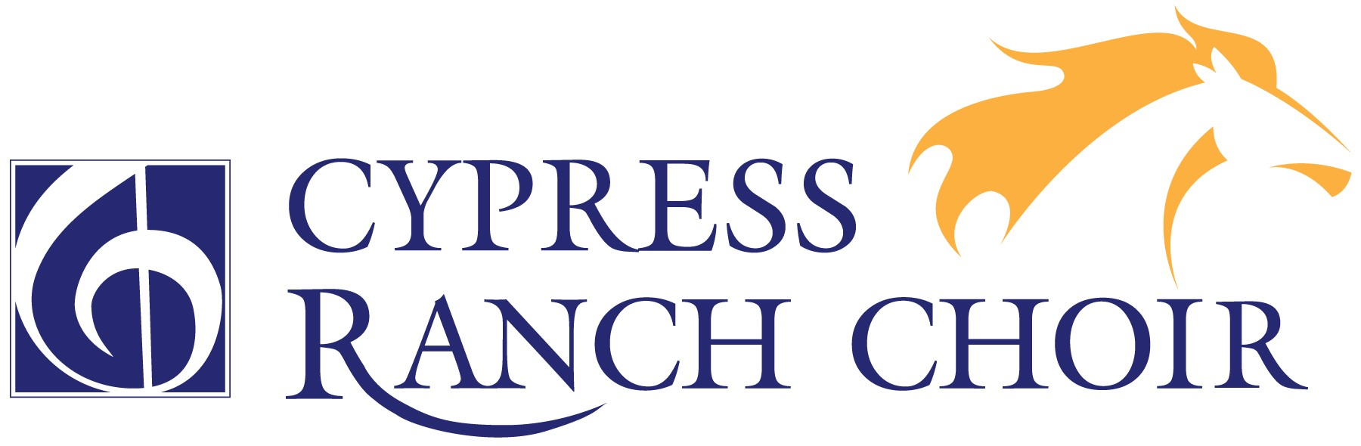

High School Night at the Opera
Every year the Cypress Ranch Choir Department attends High School Night at the Opera at the Wortham Center in downtown Houston. We take a bus to the Wortham Center and come back to school after the conclusion of the performance.

Opera: Rigoletto, by Verdi. Often regarded as Verdi’s first great masterpiece, Rigoletto is based on Victor Hugo’s story of a hunchbacked court jester who tries to protect his beautiful daughter, Gilda, from being seduced by the wanton Duke of Mantua. When passion causes him to plot the Duke’s murder, Gilda, blinded by love, spoils her father’s scheme with terrible results.
Date $$$ Due: Wednesday, September 11th
Cost: $30 for ticket and transportation (An incredible value!)
Date of Opera: Wednesday, October 30th
Who is Invited: All Choir Students and Choir Parents

IMPORTANT THINGS TO KNOW:
- The bus is leaving from Cy-Ranch at 5:00 PM to go to the Wortham Center. Students are required to ride the bus. Parents may ride with us if they like. Please indicate the number of bus riders on this form.
- Make sure to eat dinner before we leave, since we will not have a meal or snack opportunity during this field trip.
- Dress up for the occasion. Gentlemen, wear a tie if you have one. Ladies, know that there may be a bit of a walk to the bus, and there are many stairs in the Wortham. Make your shoe choices wisely. Dress code guidelines will apply.
- The bus will arrive back at Cy-Ranch around 10:45 PM.

Please return this form and include it along with cash or check made out to “CRCPA”. Please place both form and payment together in the safe.

I give permission for my student to go to High School Night at the Opera on October 30th, and I understand that if I am not going to the opera with them, I need to be prepared to pick up my student at Cy-Ranch at approximately 10:45 PM.

Student Name

________________________________
Parent Signature

How many tickets purchased? __________

How many people will ride the bus? __________

